Class-01 Authentication

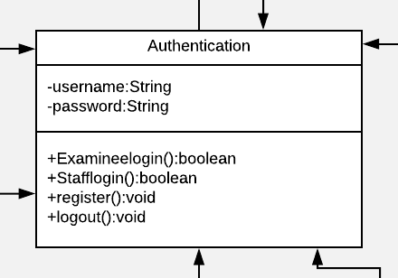

**Description**: This Authentication model class for checking user.

**Attribute Narrative**:

|  |  |  |  |  |
| --- | --- | --- | --- | --- |
| No. | Name | Description | Access Modifier | Data Type |
| 1. | username | The attribute “username” contains the  information of examinee, staff, admin, examine, Inspectors. This value is a combination of numeric and character with the minimum length of 4 characters and the maximum length of 16 characters. | private | String |
| 2. | password | The attribute “password” contains the  information of the password. This value is a combination of numeric and character with the minimum length of 4 characters and the maximum length of 16 characters. | private | String |

**Method description**:

|  |  |  |  |  |  |
| --- | --- | --- | --- | --- | --- |
| No. | Name | Description | Access  Modifier | Input  Arguments | Return  Type |
| 1. | Examineelogin | For checking examinee identified in database | public | - | Boolean |
| 2. | Stafflogin | For checking staff identified in database | public | - | Boolean |
| 3. | register | Examinee Registration for system | public | - | void |
| 4. | logout | Exit system | public | - | void |

Class-02 Registration

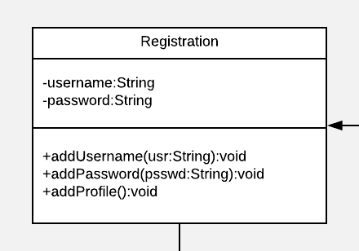

**Description**: This Registration model class for register examinee.

**Attribute Narrative**:

|  |  |  |  |  |
| --- | --- | --- | --- | --- |
| No. | Name | Description | Access Modifier | Data Type |
| 1. | username | The attribute “username” contains the  information of examinee. This value is a combination of numeric and character with the minimum length of 4 characters and the maximum length of 16 characters. | private | String |
| 2. | password | The attribute “password” confirmation the information of examinee. This value is a combination of numeric and character with the minimum length of 4 characters and the maximum length of 16 characters. | private | String |

**Method description**:

|  |  |  |  |  |  |
| --- | --- | --- | --- | --- | --- |
| No. | Name | Description | Access  Modifier | Input  Arguments | Return  Type |
| 1. | addUsername | Add username of examinee identified in database | public | usr:String | void |
| 2. | addPassword | Add confirmation of username in database | public | psswd:String | void |
| 3. | addProfile | Examinee Registration for system | public | - | void |

Class-03 Profile

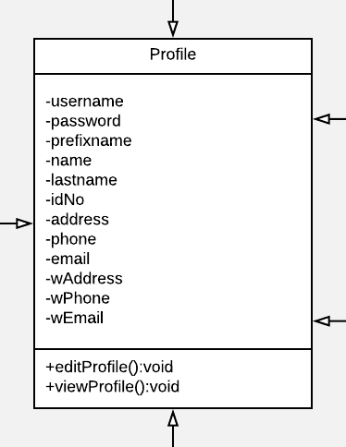

**Description**: This Profile model class for contain information.

**Attribute Narrative**:

|  |  |  |  |  |
| --- | --- | --- | --- | --- |
| No. | Name | Description | Access Modifier | Data Type |
| 1. | username | The attribute “username” contains the  information of examinee. This value is a combination of numeric and character with the minimum length of 4 characters and the maximum length of 16 characters. | private | String |
| 2. | password | The attribute “password” is confirmation the information of username. This value is a combination of numeric and character with the minimum length of 4 characters and the maximum length of 16 characters. | private | String |
| 3. | prefixname | Prefix of name. | Private | String |
| 4. | name | Name of user. | Private | String |
| 5. | lastname | Last name of user. | Private | String |
| 6. | idNo | ID card number of user. | Private | String |
| 7. | address | Address of user. | Private | String |
| 8. | phone | Phone number of user. | Private | String |
| 9. | email | E-mail of user | Private | String |
| 10. | wAddress | Work address of user. | Private | String |
| 11. | wPhone | Work phone number of user. | Private | String |
| 12. | wEmail | Work E-mail of user. | private | String |

**Method description**:

|  |  |  |  |  |  |
| --- | --- | --- | --- | --- | --- |
| No. | Name | Description | Access  Modifier | Input  Arguments | Return  Type |
| 1. | editProfile | Edit profile information of user | public | usr:String | Void |
| 2. | viewProfile | Show profile information of user | public | psswd:String | Void |

Class-04 AdminSystem

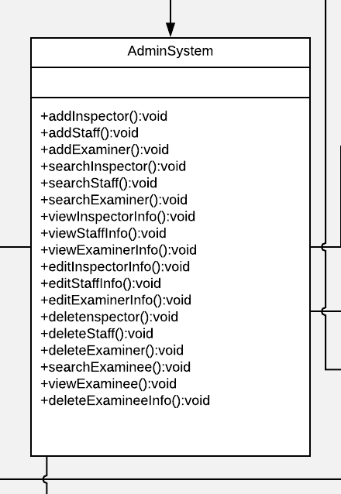

**Description**: This AdminSystem model class for administrator.

**Method description**:

|  |  |  |  |  |  |
| --- | --- | --- | --- | --- | --- |
| No. | Name | Description | Access  Modifier | Input  Arguments | Return  Type |
| 1. | addInseptor | Add inspector account. | public | - | void |
| 2. | addStaff | Add staff account. | public | - | void |
| 3. | addExaminer | Add examiner account. | public | - | void |
| 4. | searchInspector | Search information of inspector | Public | - | Void |
| 5. | searchStaff | Search information of staff | Public | - | Void |
| 6. | searchExaminer | Search information of examiner | Public | - | Void |
| 7. | viewInspector | View information of inspector | Public | - | Void |
| 8. | viewStaff | View information of staff | Public | - | Void |
| 9. | viewExaminer | View information of examiner | Public | - | Void |
| 10. | editInspector | Edit profile information of inspector | Public | - | Void |
| 11.. | editStaff | Edit profile information of staff | Public | - | Void |
| 12. | editExaminer | Edit profile information of examiner | Public | - | Void |
| 13. | deleteInspector | Delete inspector account | Public | - | Void |
| 14. | deleteStaff | Delete inspector staff | Public | - | Void |
| 15. | deleteExaminer | Delete inspector examiner | Public | - | Void |
| 16. | searchExaminee | Search information of examinee | Public | - | Void |
| 17. | viewExaminee | View information of examinee | public | - | Void |
| 18. | deleteExamineeInfo | Delete information of examinee | Public | - | Void |

Class-05 Examinee

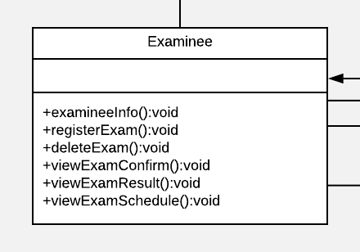

**Description**: This Examinee model class for examinee.

**Method description**:

|  |  |  |  |  |  |
| --- | --- | --- | --- | --- | --- |
| No. | Name | Description | Access  Modifier | Input  Arguments | Return  Type |
| 1. | examineeInfo | Show information of examinee | public | - | void |
| 2. | registerExam | Register examination. | public | - | void |
| 3. | deleteExam | Delete examination. | public | - | void |
| 4. | viewExamConfirm | View examination confirm. | public | - | void |
| 5. | viewExamResult | View examination result. | Public | - | Void |
| 6. | viewExamSchedule | View examination schedule. | Public | - | Void |

Class-06 Examiner

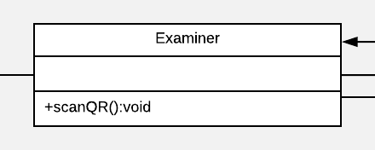

**Description**: This Examiner model class for examiner.

**Method description**:

|  |  |  |  |  |  |
| --- | --- | --- | --- | --- | --- |
| No. | Name | Description | Access  Modifier | Input  Arguments | Return  Type |
| 1. | scanQR | Scan QR code for view examinee’s information | public | - | void |

Class-07 Staff

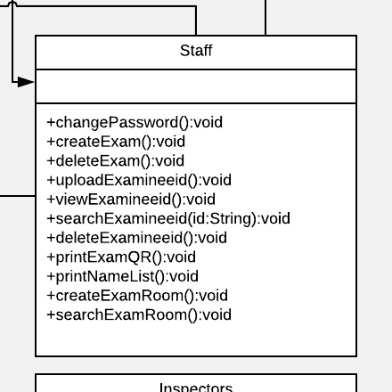

**Description**: This Staff model class for staff.

**Method description**:

|  |  |  |  |  |  |
| --- | --- | --- | --- | --- | --- |
| No. | Name | Description | Access  Modifier | Input  Arguments | Return  Type |
| 1. | changePassword | Change password of staff | public | - | Void |
| 2. | createExam | Create examination | Public | - | Void |
| 3. | deleteExam | Delete examination | Public | - | Void |
| 4. | uploadExamineeID | Upload the examinees’ identification documents. | Public | - | Void |
| 5. | viewExamineeId | View the examinees’ identification documents. | Public | - | Void |
| 6. | searchExamineeId | Search for the examinees’ identification documents by examinees’ id. | Public | - | Void |
| 7. | deleteExamineeId | Delete the examinees’ identification documents | Public | - | Void |
| 8. | printExamQR | Print out the examination form from examinees with QR code | Public | - | Void |
| 9. | printNameList | Print out the examination form from examinees with QR code. | Public | - | Void |
| 10. | createExamRoom | Create the examination room. | Public | - | Void |
| 11. | searchExamRoom | Search the examination room | public | - | Void |

Class-08 Inspector

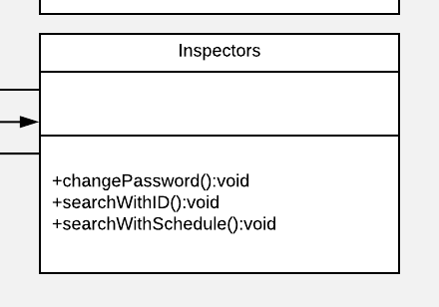

**Description**: This Inspector model class for Inspector.

**Method description**:

|  |  |  |  |  |  |
| --- | --- | --- | --- | --- | --- |
| No. | Name | Description | Access  Modifier | Input  Arguments | Return  Type |
| 1. | changePassword | Change password of inspector | public | - | void |
| 2. | searchWithID | Search the examinees by the examinee’s ID | Public | - | Void |
| 3. | SearchWithSchedule | Search the examinees by the examination schedule. | public | - | void |

Class-08 Inspector



**Description**: This Inspector model class for Inspector.

**Method description**:

|  |  |  |  |  |  |
| --- | --- | --- | --- | --- | --- |
| No. | Name | Description | Access  Modifier | Input  Arguments | Return  Type |
| 1. | changePassword | Change password of inspector | public | - | void |
| 2. | searchWithID | Search the examinees by the examinee’s ID | Public | - | Void |
| 3. | SearchWithSchedule | Search the examinees by the examination schedule. | public | - | void |

Class-09 Examination

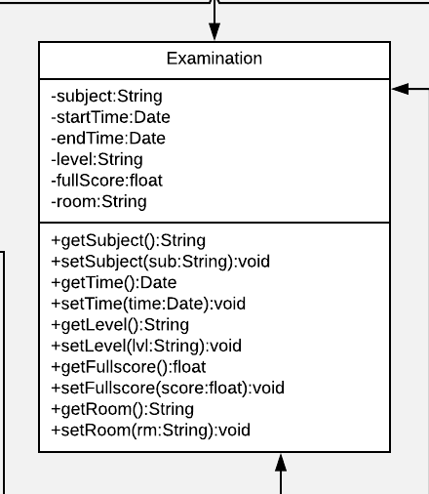

**Description**: This Examination model class for Examination.

**Attribute Narrative**:

|  |  |  |  |  |
| --- | --- | --- | --- | --- |
| No. | Name | Description | Access Modifier | Data Type |
| 1. | subject | Name of subject | private | String |
| 2. | startTime | Start examination time | private | String |
| 3. | endTime | End examination time | Private | String |
| 4. | Level | Level of examination | Private | String |
| 5. | fullScore | Limit of score | Private | String |
| 6. | room | Examination room | private | String |

**Method description**:

|  |  |  |  |  |  |
| --- | --- | --- | --- | --- | --- |
| No. | Name | Description | Access  Modifier | Input  Arguments | Return  Type |
| 1. | setSubject | Set name of subject | public | usr:String | void |
| 2. | getSubject | Return name of subject | public | psswd:String | void |
| 3. | setTime | Set time of examination | public | - | void |
| 4. | getTime | Return time of examination |  |  |  |
| 5. | setLevel | Set level of examination |  |  |  |
| 6. | getLevel | Return level of examination |  |  |  |
| 7. | setfullScore | Set full score |  |  |  |
| 8. | getFullScore | Return full score |  |  |  |
| 9. | setRoom | Set room of examination |  |  |  |
| 10. | getRoom | Return room of examination |  |  |  |

Class-10 Score

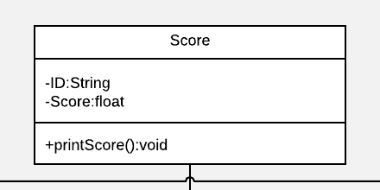

**Description**: This Score model class for score.

**Attribute Narrative**:

|  |  |  |  |  |
| --- | --- | --- | --- | --- |
| No. | Name | Description | Access Modifier | Data Type |
| 1. | ID | Identify of examinee | private | String |
| 2. | Score | Score of examinee | private | float |

**Method description**:

|  |  |  |  |  |  |
| --- | --- | --- | --- | --- | --- |
| No. | Name | Description | Access  Modifier | Input  Arguments | Return  Type |
| 1. | printScore | Print score of examinee | public | - | void |

Class-11 MoblieApp

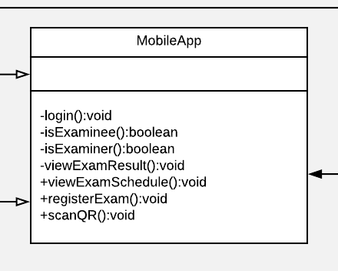

**Description**: This MoblieApp model class for MoblieApp.

**Method description**:

|  |  |  |  |  |  |
| --- | --- | --- | --- | --- | --- |
| No. | Name | Description | Access  Modifier | Input  Arguments | Return  Type |
| 1. | login | log in to the mobile application | public | - | void |
| 2. | isExaminee | Checking for examinee | Public | - | void |
| 3. | isExaminer | Checking for examiner | Public | - | Void |
| 4. | viewExamResult | View the examination result on the mobile application | Public | - | Void |
| 5. | viewExamSchedule | View the examination schedule on the mobile application. | Public | - | Void |
| 6. | viewRegisterExam | View the registration of the examination on the mobile application | Public | - | Void |
| 7. | scanQR | Scan QR code on mobile application | Public | - | Void |